**Blazor wasm consumes ChatGPT API**

JL 2023-05-08

I wanted to implement **ChatGPT API** service in a **Blazor wasm** project. Since no sample found in the web search, I decided to create myself follow a DeskTop sample.

1. Create a default Blazor wasm project in **Visual Studio Community 2022** with **.NET 7.0**
2. **Nuget** Install the package **Betalgo.OpenAI.GPT3**. This is the **ChatGPT API**
3. **Nuget** Install the package **Radzen.Blazor**. This is used for client site layout
4. _Imports.razor: Added
   1. @using Radzen
   2. @using Radzen.Blazor
5. index.html: Added
   1. <link rel="stylesheet" href="_content/Radzen.Blazor/css/default-base.css">
   2. <link rel="stylesheet" href="_content/Radzen.Blazor/css/default.css">
6. Created Index.razor.cs: Added
7. Modified Index.razor: Added

The changes in the **solution** looks like following red box highlighted files:

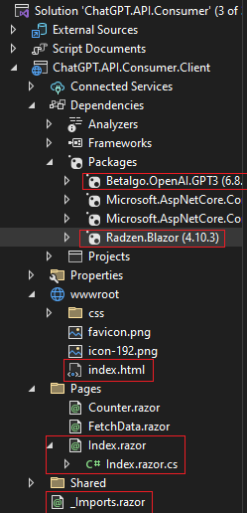

Index.razor:

@page "/"

<**PageTitle**>Index</**PageTitle**>

<h1>@title</h1>

<div class="row">

<div class="col-md-4">

<**RadzenCard**>

<div class="row">

@lblRequest <**RadzenTextBox** **Placeholder**=@lblRequest @bind-Value=@txtRequest Class="w-100" />

<br />

<br />

<br />

<center>

<button class="btn btn-primary" @onclick="(() => Submit())">@submit</button>

</center>

</div>

</**RadzenCard**>

</div>

<div class="col-md-8">

<**RadzenCard**>

<p>

<b>@lblResponse</b>

</p>

<p>

@txtResponse

</p>

</**RadzenCard**>

</div>

</div>

<br />

<br />

Index.razor.cs:

using OpenAI.GPT3;

using OpenAI.GPT3.Managers;

using OpenAI.GPT3.ObjectModels.RequestModels;

using OpenAI.GPT3.ObjectModels;

using System.Reflection;

namespace ChatGPT.API.Consumer.Client.Pages

{

public partial class Index

{

string title = "ChatGPT API Consumer",

lblRequest = "",

lblResponse = "",

txtRequest = "",

txtResponse = "",

submit = "Submit";

protected override async Task OnInitializedAsync()

{

base.OnInitialized();

var isEnglish = Thread.CurrentThread.CurrentCulture.Name == "en-US";

if (isEnglish)

{

title = "ChatGPT API";

lblRequest = "Input Request：";

lblResponse = "Response：";

submit = "Submit";

}

else

{

title = "人工智能服务";

lblRequest = "输入咨询问题：";

lblResponse = "人工智能答复：";

submit = "提交";

}

}

/// <summary>

/// Button click event handler

/// </summary>

private async Task Submit()

{

var gpt3 = new OpenAIService(new OpenAiOptions()

{

ApiKey = "YOUR OWN CHATGPT SECURITY KEY HERE"

});

var completionResult = await gpt3.ChatCompletion.CreateCompletion

(

new ChatCompletionCreateRequest()

{

Messages = new List<ChatMessage>(new ChatMessage[] { new ChatMessage("user", txtRequest) }),

Model = Models.ChatGpt3_5Turbo,

Temperature = 0.5F,

MaxTokens = 100

}

);

if (completionResult.Successful)

{

foreach (var choice in completionResult.Choices)

{

txtResponse = choice.Message.Content;

Console.WriteLine(choice.Message.Content);

}

}

else

{

if (completionResult.Error == null)

{

throw new Exception("Unknown Error");

}

Console.WriteLine($"{completionResult.Error.Code}: {completionResult.Error.Message} ");

}

}

}

}

**Please note**:

1. The code ApiKey = "YOUR OWN CHATGPT SECURITY KEY HERE" means that: To run this sample, you need to get your own security key from login in your account in **ChatGPT** website. If not clear, please googling the web: How to get own ChatGPT API Key?. Or check: <https://www.awesomescreenshot.com/blog/knowledge/chat-gpt-api>
2. Model = Models.ChatGpt3_5Turbo: The model is the most current one. Changing to others might cause app no more work

Run the application. It should show up following default state screenshot:

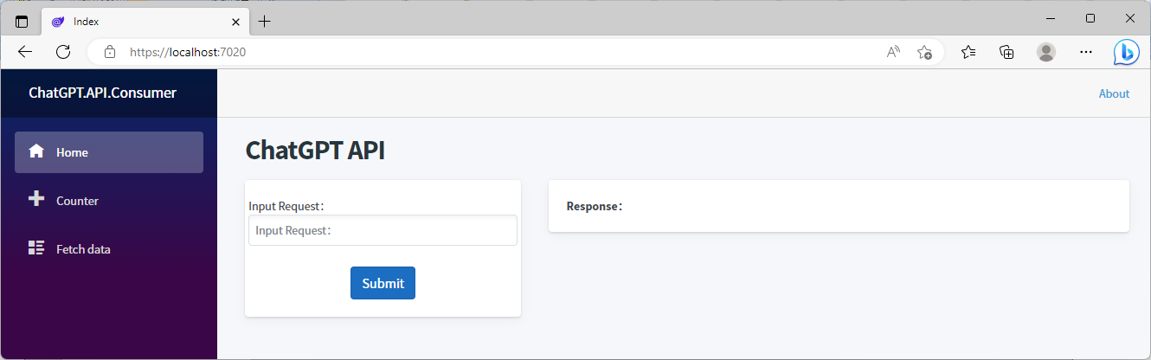

Try to prompt “what is the distance between Toronto to Montreal?”. Click the button Submit. It gives a result on the right panel:”The distance between Toronto and Montreal is approximately 542 kilometers (337 miles) by road or 504 kilometers (313 miles) by are.”

